E-COMMERCE ORDER MANAGEMENT DATABASE SYSTEM

WEEK 3: SELLER AND INVENTORY MANAGEMENT SYSTEM

INVENTORY MANAGEMENT TASKS

1. Display All Available Products
This operation is used to display all products that are currently available in the inventory. It helps to identify the products that have sufficient stock and are available for sale.
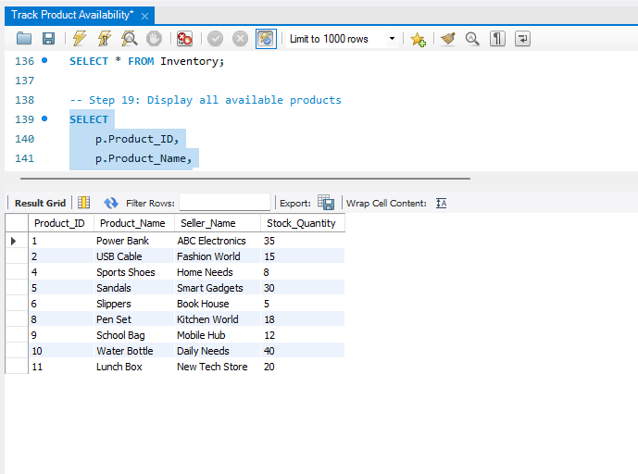

2. Find Products That Are Out of Stock
This operation is used to identify products that have no available stock. It helps the seller or administrator identify products that require stock replenishment.
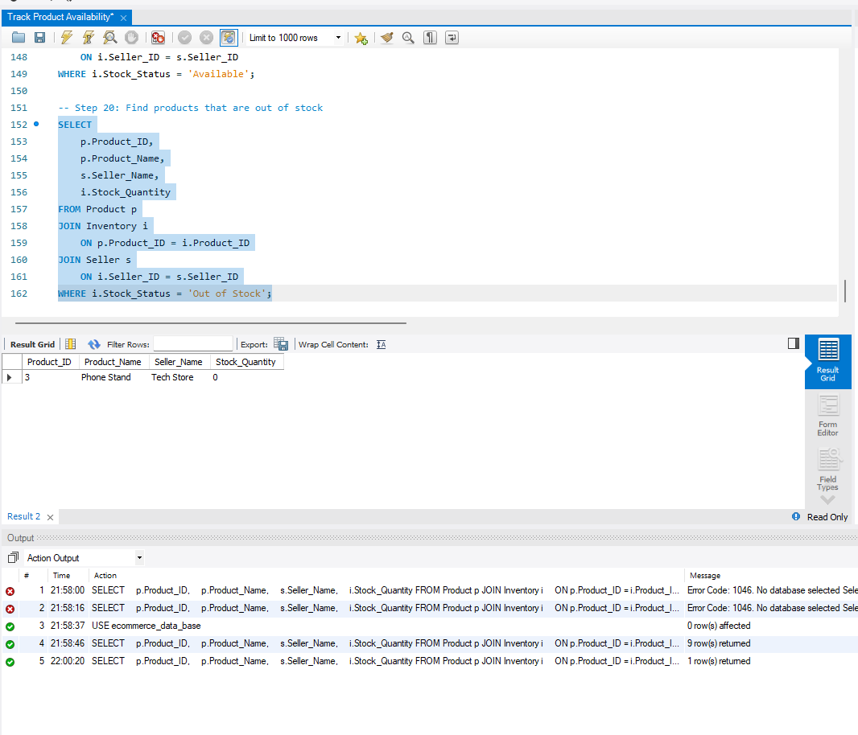

3. Identify Products with Stock Quantity Less Than 10
This operation is used to identify products with a stock quantity of less than 10 units. It helps in monitoring low-stock products and planning new stock arrivals.
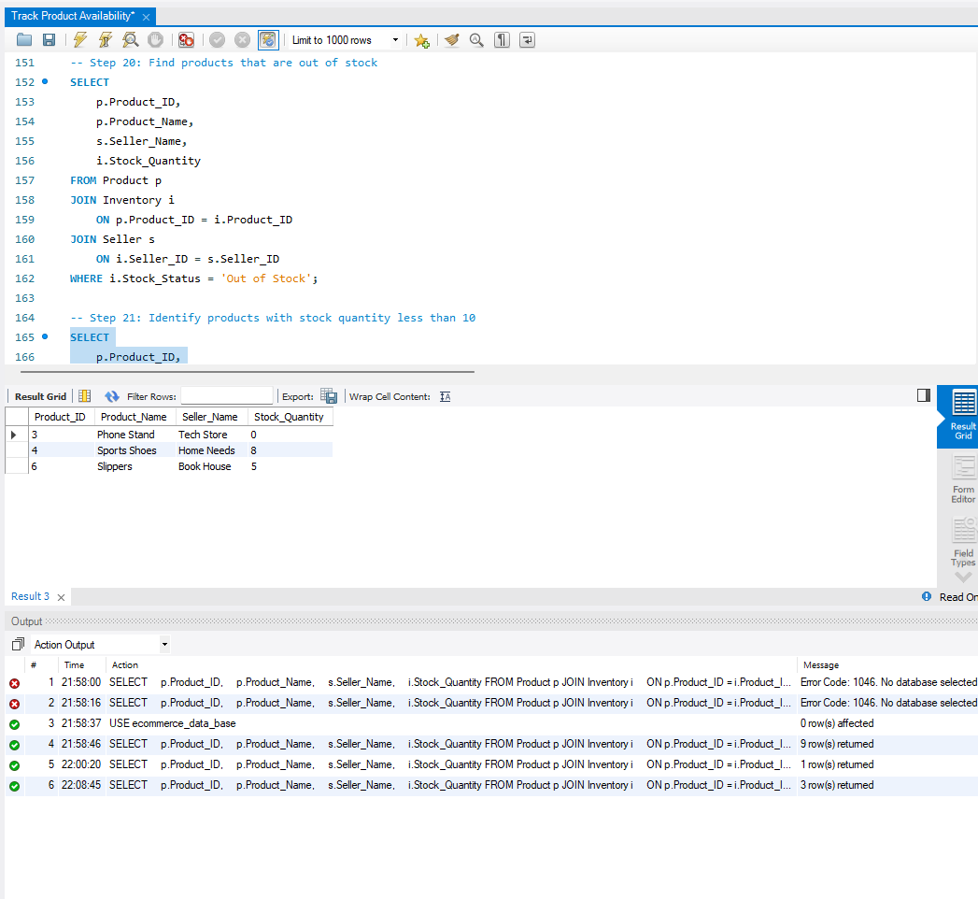

4. Update Inventory After New Stock Arrival
This operation is used to update the inventory when new stock arrives. The existing stock quantity is increased, the stock status is updated as available, and the latest update date is recorded.
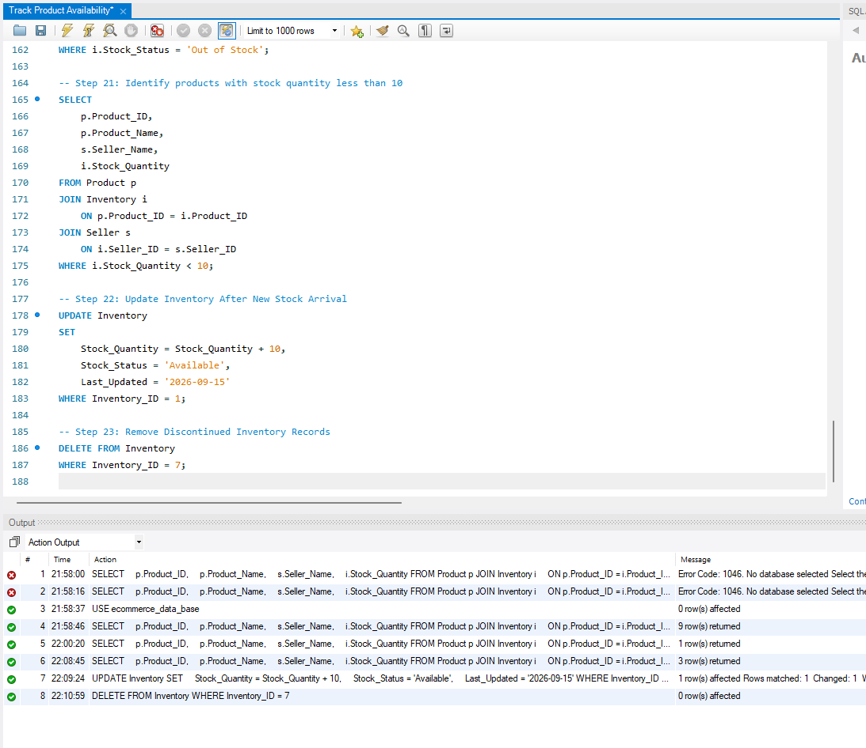

5. Remove Discontinued Inventory Records
This operation is used to remove inventory records related to discontinued products or records that are no longer required. It helps keep the inventory information organized and up to date.

6. Task Summary
S.No | Task | Purpose
1 | Display All Available Products | To identify products currently available for sale
2 | Find Out-of-Stock Products | To identify products with zero stock
3 | Identify Low-Stock Products | To find products with stock quantity less than 10
4 | Update Inventory After New Stock Arrival | To maintain the latest stock information
5 | Remove Discontinued Inventory Records | To remove unnecessary inventory records

7. Conclusion
The inventory management tasks help to monitor and maintain product stock effectively. They provide information about available, out-of-stock, and low-stock products and help update or remove inventory records when required. These tasks support proper inventory management in the E-Commerce Order Management Database System.

